ASSIGMENT 9

Lab Task: Round Robin CPU Scheduling (Time Quantum = 3 ms)
A system receives the following processes NOT in arrival order:
Process | Arrival Time (AT) | Burst Time (BT)
P1 | 4 | 7
P2 | 0 | 5
P3 | 6 | 3
P4 | 2 | 9
P5 | 1 | 4
Student Tasks
- Do NOT reorder by arrival time.
Simulate exactly as given.
- Apply Round Robin Scheduling with Time Quantum = 3 ms.
- Draw the complete Gantt Chart.
- Compute for each process:
  - Completion Time (CT)
  - Turnaround Time (TAT = CT − AT)
  - Waiting Time (WT = TAT − BT)
- Compute:
  - Average TAT
  - Average WT
- Write a C program that performs RR scheduling.
- Compare your manual result with the program output.

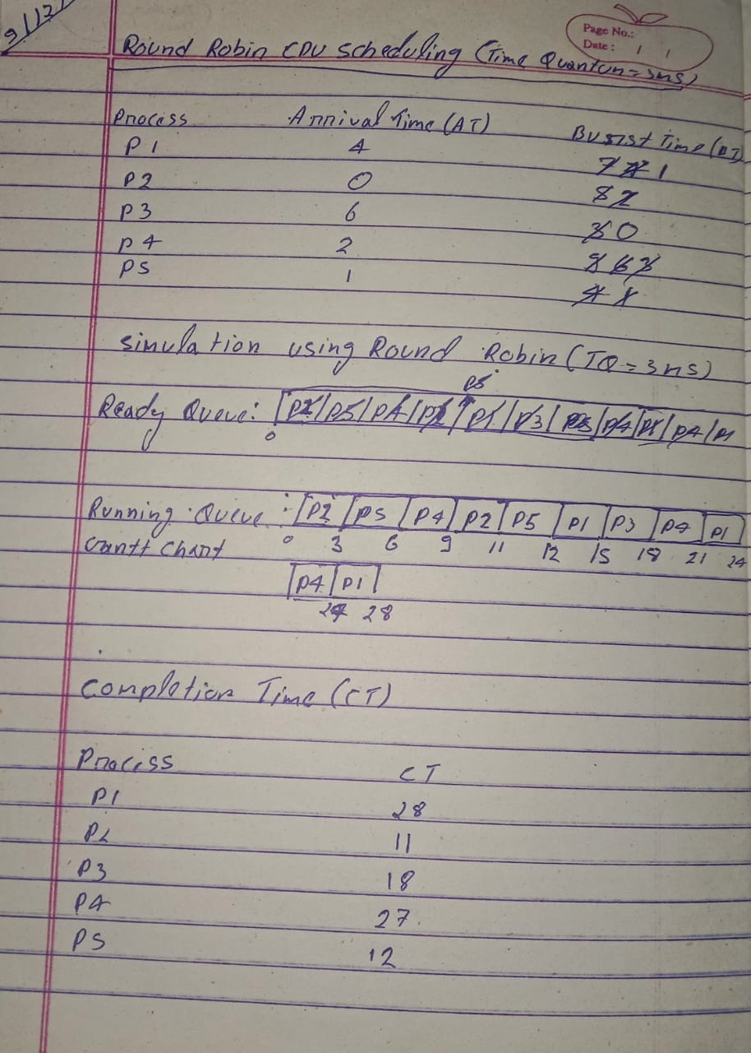
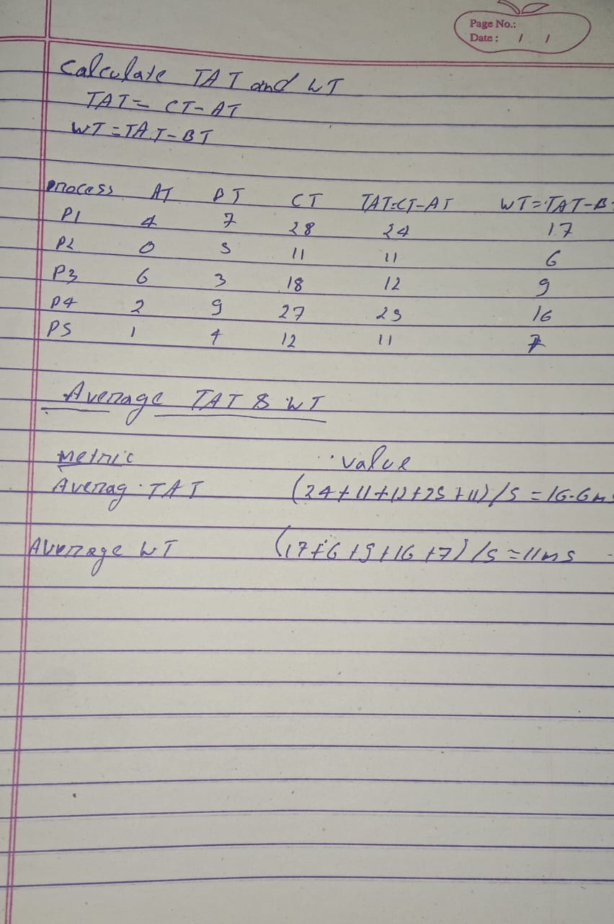
C PROGRAM CODE
